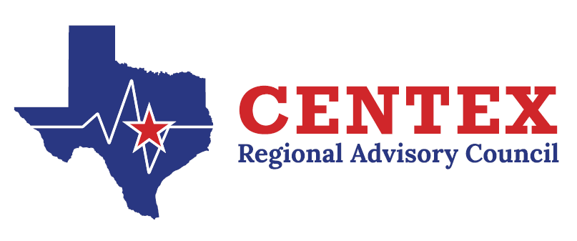
Committee: Stroke Date/Time/Type: September 25th, 2024/0900/in person
Chair: Penelope McCabe Vice Chair: Enid Cooke Staff: Christine Reeves
Members Attendance: See sign in roster.
TOPIC | DISCUSSIONS | RECOMMENDATIONS/ACTIONS | FOLLOW-UP/DATE | RESPONSIBLE PARTY
Welcome & Call to Order | Meeting started at 0906 by Chair. | N/A | N/A | N/A
Emergency Healthcare System Items | N/A | N/A | N/A | N/A
Approval of Minutes | N/A | Michael Crawford motioned with date change to approve minutes. Enid seconded motion. Motion carried. | N/A | N/A
Updates from State Meetings | EMS Pediatric Stroke was approved by the Stroke Committee and moved forward to GETAC Council. Promoting getting the patient to the appropriate facility. Discussion regarding the Zodiac trial. | Penelope will send the Zodiac Trial information out to the group. | N/A | Penelope McCabe
TNKase vs Alteplase | December 18th Advent Central Tx will be transitioning to TNKase. BSW will be transitioning in March of 2025. Discussion to stop using the alteplase tool as it was not being completed on most patients since moving to electronic documentation. | Motion by Enid to no longer complete the regional alteplase tool. Motion seconded by Chancy. Motion carried. | N/A | N/A
Stroke T-Shirt & Outreach | Fast Shirts were order & hoodies. Discussion about FAST vs. BFAST. Several items ordered from AHA for Stroke outreach. Outreach GO BOXES being put together for use when doing outreach. | N/A | N/A | N/A
Performance Improvement. | RAC Data Collaborative Reports – Penelope is on the RDC Committee and willing to bring up and issues needed. Becky unsure about RDC access. Discussion about the National Risk factors and missing smoking as a risk factor.  EMS Education –  October EMS Education will not be occurring. Discussion about how to move forward with the education. | N/A | N/A | N/A
Central Texas Outreach & Prevention Collaborative Update | Stomp Out Stroke in June was cancelled. World Stroke Day is 10/25 – Rollins Brook will be doing something. Will need to send out the playbook via email. Discussion about providing data at events even in another month. | N/A | N/A | All
Designation/Survey Updates | Advent – mid-late October JACHO Survey.  SHH - June | N/A | N/A | N/A
Next Meeting & Adjourn | N/A | 12.18.2024 at 9:00 am  Meeting adjourned | N/A | N/A

Committee Chair Signature: ___________________________________________ Date: _____________________

