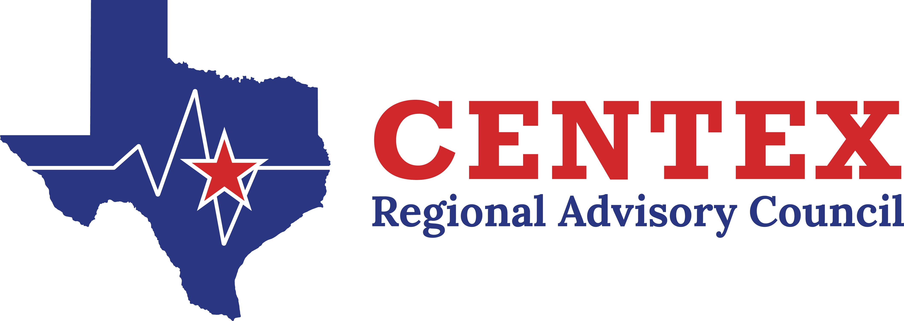

**Emergency Department (ED) Committee**

**May 14th, 2025**

**Agenda**

1. **Welcome and Introductions**
2. **Emergency Healthcare System Items**
3. **Action and/or Discussion on the following items:**
   1. **Approval of Previous Meeting Minutes……**
   2. **Recommendations from Other Committees/Workgroups**
   3. **Pulsara**
4. Usage….Update
   1. **Sepsis Alert Discussion**
5. See attached “Guidelines” used by other regions.
   1. **Pediatric Readiness Program**
      1. National Performance Project
      2. Regional PECC Update
   2. **Geriatric Population**
      1. Interaction with nursing homes/assisted living Update
   3. **Other Regional Discussion/Update**

* **EHSP**

1. **Open Forum**
2. **Next Meeting** – August 13th, 2025 1600-1700
3. **Adjourn**