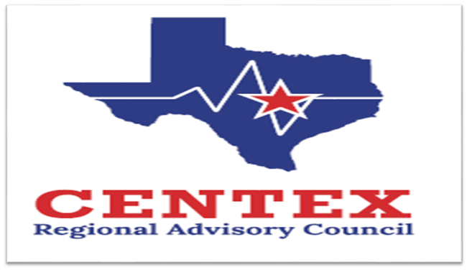**Our Mission and Initiatives**

**Enhancing Emergency Healthcare:** We support member organizations in delivering the highest level of emergency healthcare to reduce morbidity and mortality and improve patient outcomes.

**Promoting Cooperation:** We encourage collaborative activities among member organizations and provide a platform to resolve conflicts related to patient care.

**Community Education:** We facilitate educational programs for the public to raise awareness about an inclusive trauma system, with a strong emphasis on prevention.

**EMS Operations Committee**

**March 26th, 2025**

**AGENDA**

1. **Call to Order and Introductions**
2. **Approval of the Previous Meeting Minutes**
3. **Emergency Healthcare System Items**
4. **Action and/or Discussion on the following items:**
   1. **Recommendations from Other Committees/Workgroups**

Perinatal requested pre-eclampsia protocol (IE: Mag & Labetalol use)

* 1. **State Meetings**
  2. **RAC Rule/Self-Assessment**
  3. **EMS/County Funding 8.31.2025**
  4. **SB8 Funding Closed**
  5. **Pediatric Initiatives**
     1. EMS-C Pediatric Recognition Program…..update
     2. EMS-C Pediatric Readiness Survey…..update
  6. **Pulsara Updates**
  7. **EMS Performance Improvement**
     + Was the temperature recorded on all transported patients?
     + For possible cardiac patients, was a 12-lead completed within 10 minutes of arrival on scene?
     + For possible stroke patients, was a stroke scale and LVO scale documented?
  8. **Training Opportunities**
  9. **RAC & EMS BAA for DATA access with those using ESO**
  10. **PHWB-WG**

1. **Air Medical**
2. **Open Forum**
3. **Next Meeting** – June 26th, 2025 1400-1530
4. **Adjourn**