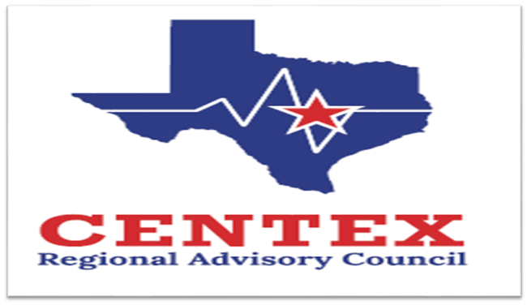**Our Mission and Initiatives**

**Enhancing Emergency Healthcare:** We support member organizations in delivering the highest level of emergency healthcare to reduce morbidity and mortality and improve patient outcomes.

**Promoting Cooperation:** We encourage collaborative activities among member organizations and provide a platform to resolve conflicts related to patient care.

**Community Education:** We facilitate educational programs for the public to raise awareness about an inclusive trauma system, with a strong emphasis on prevention.

**Stroke Committee**

**March 26th, 2025**

**0800-0930**

**CTCOG, Room D10**

**Agenda**

1. **Call to Order and Introductions**
2. **Approval of Previous Meeting Minutes**
3. **Update from State Meeting**
4. **Emergency Healthcare System Items**
5. **Action and/or Discussion on the following items:**
   1. **CVA Chair and Co-Chair election (12/24)**
   2. **CVA meeting schedule discussion**
   3. **RAC Rule and Self Assessment**
   4. **TNKase vs Alteplase Discussion, as needed**
   5. **Regional Stroke System Plan**
6. Pedi CVA
   1. **Performance Improvement** 
      1. RAC Data Collaborative Reports
      2. EMS Education
   2. **Central Texas** **Outreach & Prevention Collaborative Update**
      1. Stomp Out Stroke
   3. **Designation/Survey Updates**
7. **Open Forum**
8. **Next Meeting** –June 26th, 2025 0800-0930 or TBD
9. **Adjourn**