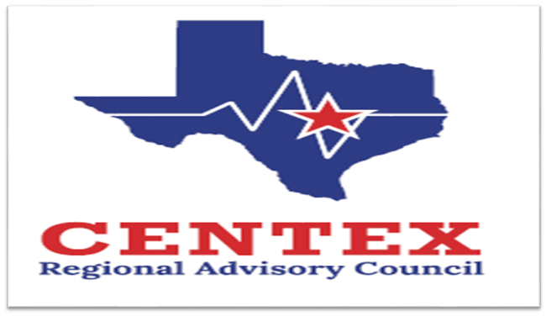**Our Mission and Initiatives**

**Enhancing Emergency Healthcare:** We support member organizations in delivering the highest level of emergency healthcare to reduce morbidity and mortality and improve patient outcomes.

**Promoting Cooperation:** We encourage collaborative activities among member organizations and provide a platform to resolve conflicts related to patient care.

**Community Education:** We facilitate educational programs for the public to raise awareness about an inclusive trauma system, with a strong emphasis on prevention.

**Trauma Committee**

**March 26th, 2025**

**COG, Room D10**

**Agenda**

1. **Call to Order**
2. **Approval of Previous Meeting Minutes**
3. **Update from State Meetings**
4. **Emergency Healthcare System Items**
5. **Action and/or Discussion on the following items:**
   1. Regional Trauma System Plan
   2. RAC Focus Programs/Focuses

1. Pediatric Readiness Project Updates

1. Child Passenger Safety Program
2. Water Safety
3. Pedestrian Safety – all ages
4. Suicide & Mental Health Awareness
   1. Other Committee(s) Update(s)/Need(s)
5. **Regional Trauma Registry Discussion**
   1. ESO Update and Go Live…Updates
   2. Trauma Registry Data pre-plan for facilities not using ESO
6. **Registry/Performance Improvement**
7. **Regional Updates**
   1. Central Texas Outreach & Prevention Collaborative Updates
   2. CENTEX Family Violence Task Force Update
   3. Designation/Survey Update(s)
8. **Open Forum**
9. **Next Meeting** – June 26th, 2025 0930-1100
10. **Adjourn**