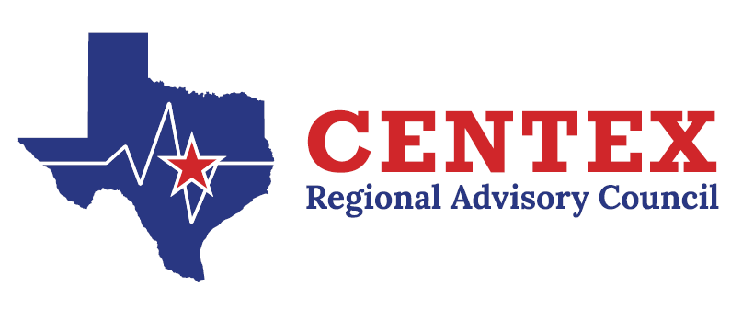

Cardiac Committee
June 26th, 2025
COG, TEAMS

Agenda

- Call to Order and Introductions

- Approval of Previous Meeting Minutes
3.26.25
- Update from State Meetings, if applicable

- Emergency Healthcare System Items
A. Contract Work Group Update- RAC Rule and Self-Assessment
- Action and/or Discussion on the following items:
  - RAC Rule, Criterion, and Assessment
  - Registry/Performance Improvement
    - RAC Data Collaborative
  - Cardiac Care Education Needs
………
  - Focused Discussion
    - Pediatrics
    - Geriatrics
  - Central Texas Outreach & Prevention Collaborative Update

  - Designation Updates

- Open Forum

- Next Meeting –September 24th, 2025 @ 1245

- Adjourn

