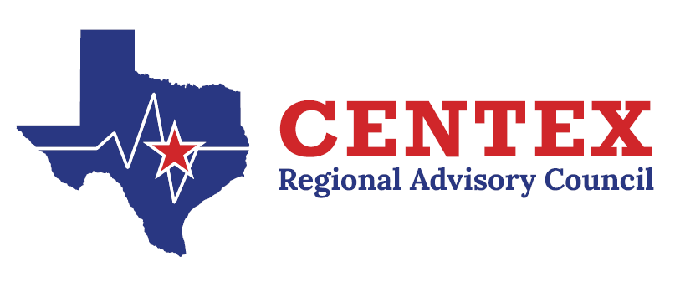
EMS Operations Committee
June 26th, 2025
COG, TEAMS
AGENDA

- Call to Order and Introductions

- Approval of the Previous Meeting Minutes
- Emergency Healthcare System Items
  - Contract Work Group Update- RAC Rule and Self-Assessment (Tim)
- Action and/or Discussion on the following items:
  - Recommendations from Other Committees/Workgroups
  - State Meetings
  - EMS/County Funding
  - Pediatric Initiatives
    - EMS-C Pediatric Recognition Program…..update
    - EMS-C Pediatric Readiness Survey…..update
  - Pulsara Updates
  - EMS Performance Improvement
    - Sepsis (Data points being found)
    - For possible cardiac patients, was a 12-lead completed within 10 minutes of arrival on scene?
    - For possible stroke patients, was a stroke scale and LVO scale documented?
  - Training Opportunities
CADS- Update (Daniel)
FTO- Update (Daniel)
  - PHWB-WG

- Air Medical

- Open Forum

- Next Meeting – September 24th, 2025 @ 1400-1530

- Adjourn

