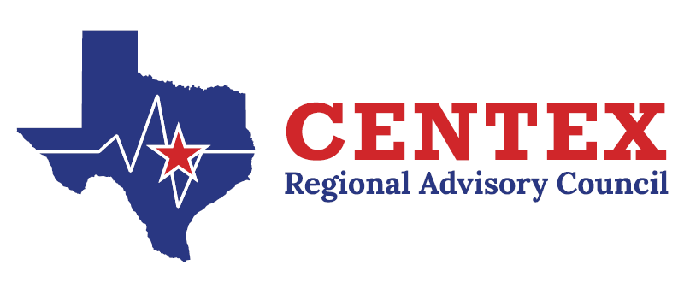

Stroke Committee
June 26th, 2025
0930-1100
CTCOG, TEAMS

Agenda

- Call to Order and Introductions

- Approval of Previous Meeting Minutes
3.26.25
- Update from State Meeting

- Emergency Healthcare System Items
  - Contract Work Group Update- RAC Rule and Self-Assessment
- Action and/or Discussion on the following items:
  - TNKase vs Alteplase Discussion, as needed (Dr. Fournier)
  - Regional Stroke System Plan
- Pedi CVA
  - Performance Improvement
    - RAC Data Collaborative Reports (Genevieve STRAC 1030-1100)
    - EMS Education-May 22 CEU update
  - Central Texas Outreach & Prevention Collaborative Update
    - Stomp Out Stroke
  - Designation/Survey Updates

- Open Forum

- Next Meeting –September 24th, 2025 @ 0930

- Adjourn

