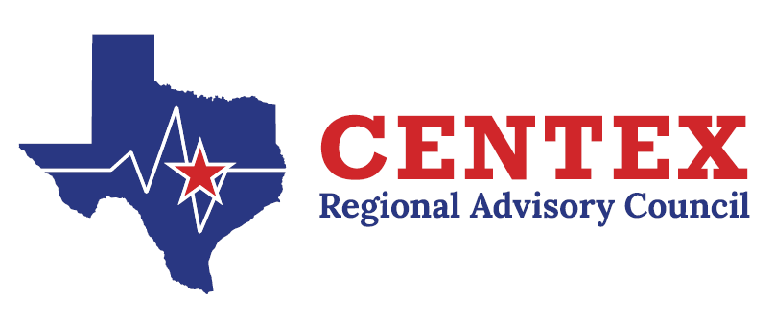
Trauma Committee
June 26th, 2025
COG, TEAMS

Agenda

- Call to Order
- Approval of Previous Meeting Minutes
3.26.25
- Update from State Meetings
- Emergency Healthcare System Items
A. Contract Work Group Update- RAC Rule and Self-Assessment
- Action and/or Discussion on the following items:
  - Regional Trauma System Plan
  - RAC Focus Programs/Focuses
1. Pediatric Readiness Project Updates
  - Other Committee(s) Update(s)/Need(s)
- Regional Trauma Registry Discussion
  - ESO…Updates (Heidi, Tracy)
  - Trauma Registry Data pre-plan for facilities not using ESO…Update (Dawn, Tracy)
- Registry/Performance Improvement

- Regional Updates
  - Central Texas Outreach & Prevention Collaborative Updates
  - Designation/Survey Update(s)
- Open Forum
- Next Meeting – September 24th, 2025 @ 0800
- Adjourn

